MODEL QUESTION PAPER
B.E. ELECTRONICS AND INSTRUMENTATION ENGINEERING

SEMESTER V

IL 351 - CONTROL ENGINEERING

Time: 3 hours Max. Marks: 100

Answer all the Questions
PART – A (10 x 2 = 20 Marks)

- Illustrate with a neat sketch the control of an automobile by the driver and identify the components of this closed loop control system.

- What are state variables? Obtain the transfer function Y(s)/U(s) of the system whose state equation is given by

X = $\left[\begin{matrix}0 & 1 \\ −2 & −3\end{matrix}\right]$X + $\left[\begin{matrix}0 \\ 1\end{matrix}\right]$U

Y = [1 5] X

- The unit step response of a system is found to produce an overshoot of 10%, rise time of 1sec and zero steady stat error. Identify the system transfer function.

- Obtain the C/R ratio of the system shown in figure q4.

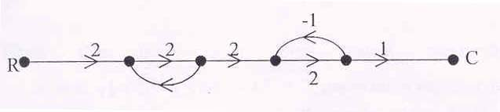

Figure q4

- Distinguish the functioning of a DC servo motor compared to a normal DC motor.

- Consider a Type I system. It is controlled through a proportional error controller under unity negative feedback. Explain how the time domain specifications change for various values of the proportional gain.

- Evaluate the closed loop stability of the system defined in figure q7 using Nyquist’plot.

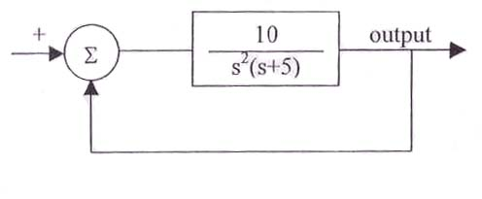
Figure q7

- Show that the phase margin of a first order system is always greater than or equal to 90 degrees for any value of DC gain.

- Illustrate a method by which the closed loop system specifications can be determined by plotting only the open loop gain and phase variations with respect to frequency.

- Distinguish the compensation provided by lag compensator to that of a PI controller.

PART – B (5 x 16 = 80 Marks)

- Consider the system shown in figure q11

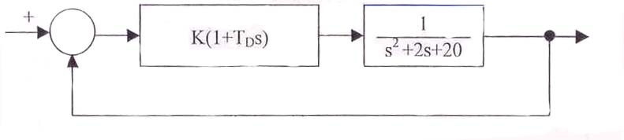
Figure q11

a) Assess the closed loop stability by Routh-Hurwitz criterion for various values of K and when TD = 1 and 5 respectively. (10)

- Determine the dominant pole of the closed loop system when K =10 by the same criterion. (6)

12.a)i) Consider the standard second order system,

$$G(s)=\frac{W_{n}^{2}}{s(s+2{δw}_{n})}$$

Show that the closed loop system bandwidth is given by
w_{b} = w_{n} $\sqrt{1−2δ^{2}+\sqrt{4δ^{4}−4δ^{2}+2}}$ under unity negative feedback (4)

ii) Design a suitable compensator for the system with the open loop transfer function.

$$G(s)=\frac{k}{s(s+3)(s+5)}$$

to meet the following specification
damping ratio δ = 0.6
setting time = t_{s} = 10 sec
velocity error constant kv ≥ 10 sec⁻¹ under unity negative feedback. (12)

(OR)

12.b)i) Distinguish the terms lag and lead compensation. Explain how decision is made on the choice of compensation required for a given system. (8)

ii) Explain the frequency domain method of designing a Lag-lead compensator. (8)

13.a)i) Consider the system whose open loop transfer function is given by

$G(s)=\frac{K}{s(s+3)(s+5)}$. Plot the root loci and determine the value of K that produces damped oscillatory response under unity negative feedback. (12)

- Can you suggest a suitable cascade controller so for the system defined in problem 13a(i) such that the root loci will not cross the imaginary axis at all. Explain.

(OR)

13.b)i) Using Block diagram reduction rules determine the Y/R ratio for the block diagram shown in figure 13(b)(i).

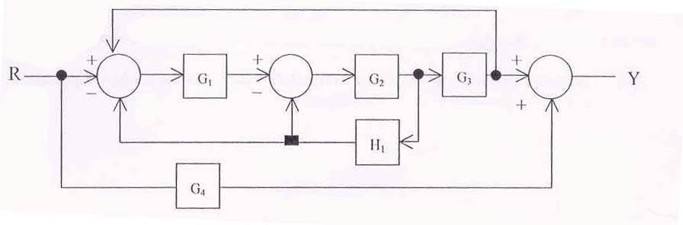

Figure 13(b)(i)

ii) Transform the block diagram shown in figure 13(b)(i) in to signal flow graph, apply Mason’s formula and verify the Y/R ratio. (8)

14.a) Determine the value of K if the gain cross over frequency w_{gc} of the unity negative feedback system with the open loop transfer function.

$$G(s)=\frac{{\text{ke}}^{−1s}}{s(s+1)(s+0\text{.}1)}$$

has to be 10 rad/sec for L = 0 using Bode plot. The asymptote Bode plot should be corrected near the corner frequencies. Determine the phase margins of the system for the two cases L=0 and L=0.5 respectively.

(OR)

14.b) Write short notes on the following

(i) Identification of systems through Bode plots (8)

(ii) BIBO stability of linear time in variant system. (8)

15.a) Consider a unity feedback system with the open loop Transfer function

$$G(s)=\frac{k}{s(s+1)(s+2)}$$

Assess the closed loop stability by Nyquist’ technique for the two cases k =1 and k=10 respectively. (16)

(OR)

15.b)i) Consider a system with the open loop transfer function $G(s)=\frac{5(s+2)}{s(s−1)}$Assess the stability of the unity negative feedback closed loop system using the Nyquist’ criterion. (10)

ii) Determine whether there will be any closed loop pole to right of 2+jw line in the complex plane for the system defined in 15b(i) using Nyquist’ criterion. (6)

-----

